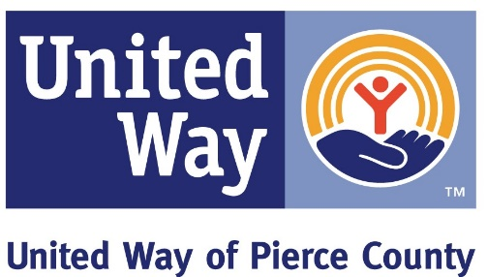

Strong Families | Stories of Hope

On the Right Track
‘Linda’ had been living in poverty but was determined to succeed. She had a BA in Advertising and worked in the field for a while, yet knew she wanted more. She knew there were trades with long-term career opportunities and that the work was in demand. After completing a trades rotation program, she was placed in ANEW’s Carpenters Apprenticeship where she excelled. She got a job work within two weeks on the Sound Transit Rail Project, where she received multiple support services resources, including obtaining her tools and work gear. She was able to get her initiation to the union paid with support service funds, which allowed her to take the job and be on the dispatch list. As a first-year carpenter apprentice, her starting wage is $25.25 and Linda truly enjoys her job. Working for Sound Transit will provide a great career because of high demand for light rail expansion and maintenance.

Moving Past Evictions
‘Mary’ had been evicted and was denied for several market rate apartments when she entered into Associated Ministries Renters Readiness monthly course. She quickly learned the importance of honest communication to help build trust with property managers. Afterward the course, she applied for an apartment and was honest about her barriers. The landlord called the case manager to request support in ensuring that the family maintained a truthful and upfront attitude throughout the entire tenancy. Sara’s family was able to move in and has remained happily housed. “We were so scared to tell her the truth about that eviction, but you see, that’s why she let us in-- because we told her the truth.” -- Mary

Education is Within Reach
Before coming to The REACH Center, ‘Rigo’ had been living in Washington for two years but had been unable to improve his education because all he was overwhelmed from working to pay his rent and child support. He was unaware that he could engage in free GED services as well as an array of case management services. In addition to working on his GED, Rigo got emergency dental care, a photo ID and birth certificate as well as onsite mental health counseling. Rigo is clearly creating a pathway out of poverty and into self-sufficiency.

A New Life
A very pregnant woman named ‘Martha’ came into the Rescue Mission’s Family Shelter seeking help. During her intake, Martha revealed she had just left her husband who had problems with drugs and alcohol and was verbally abusive. While she escaped a hostile environment, Martha had very little money, one past eviction and a large noisy family. In short order, Martha got connected to several resources including help with her eviction, health care, credit repair classes, financial and legal assistance and a housing voucher that will provided her with a safe home. Over the course of eight months, Martha found community, a church, a strong network of supporters and gave birth to a healthy baby boy. Martha is overjoyed and continually shares her gratitude for the chance to move forward.

