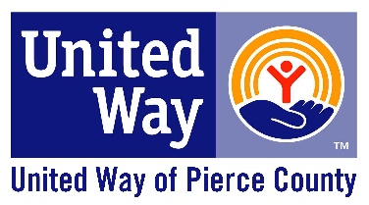FROM POVERTY TO POSSIBILITIES 2021

***A Community Approach to a Common Goal***

United Way of Pierce County (United Way) put a stake in the ground around our bold goal of lifting 15,000 households out of poverty by 2028 and moving them into financial stability. By addressing the interconnected issues affecting children and families in our community, we are ensuring that families are stronger, individuals gain stability and kids are more successful. We know one organization alone can’t solve our community's toughest problems. Moving the needle on challenging, complex issues like poverty requires individual and cross-sector collaboration that are focused on results. United Way can and does facilitate that work--one family at a time.

In 2014, 2016, and again in 2020, we commissioned ALICE studies to measure populations in our communities who are Asset-Limited, Income-Constrained, and Employed (ALICE). The ALICE population represents those among us who are working but are living paycheck to paycheck due to childcare costs, transportation challenges, high cost of living and so much more. In essence, these individuals/families are one paycheck away from being ‘in the system.’ According to the research, in 2018, 23% of households in Pierce County were considered to be ALICE with another 8% of households living at or below the poverty line for a total of 31% of families who were struggling to get by.

For 2021, the COVID-19 pandemic continued to cause disruptions in the economy along with the ongoing health crisis. Supply chain issues and inflation caused many families to struggle with meeting their basic needs. By working with organizations, collaborative partnerships, and those directly impacted by poverty, we continued to work together to help families meet their essential needs and to move households from crisis to stable to self-sufficient and – ultimately – to thriving. To make it through this crisis, however, inequities in federal and state systems need to be addressed, and that was the focus of this year’s From Poverty to Possibility summit.

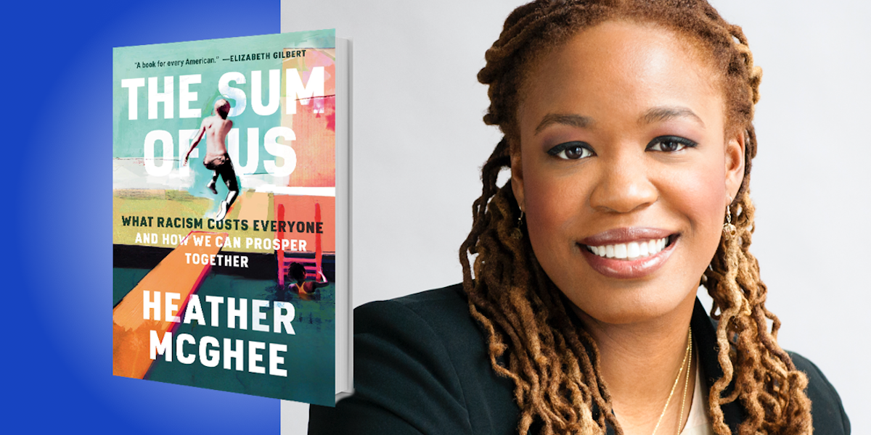

# **Key themes from this year’s summit were:**

1. **Poverty is a policy choice.** We are not using the power of government to ensure all people are safe, secure and have their basic needs met.

“The Solidarity Dividend: the idea of gains that we can unlock but only if we can come together across lines of race.”

*-Heather McGhee*

1. **Racism is antithetical to a perfect market economy.** In a perfect model, there would be no racism and people would be paid equitably according to the work they do. If wages are not equitable, we will be vulnerable in EVERY epidemic…in EVERY economic episode we face.
2. **Be comfortable being uncomfortable.** This work is so important that we can’t avoid the tough conversations and challenging environments.
3. How we behave as a community, and how we support each other, as a community is absolutely essential. **When we lift up 15,000 folks, it benefits all of us and it defines who we are.**

# **Heather McGhee**

**“Why does it seem like we can’t have nice things?”**

* Why does it seem like we can’t have nice things? Things like universal childcare; universal, affordable health care; wages that keep workers out of poverty; a well -funded school in every neighborhood; reliable modern infrastructure. These are the things that a country with our wealth should be able to provide for its people…and yet, we don't.
* Year after year, inequality has grown worse and policies are not keeping up. The cost of racial inequality actually costs trillions in terms of loss of economic growth. We need more families to feel secure and be able to thrive, innovate, and invest in their futures. We need more economic security, which is good for our GDP and our overall growth as a nation.
* The most pressing contributor to our economic dysfunction is this idea of a zero sum game…the idea that there is sort of a fixed pie of wellbeing. If I get a larger slice, you might get a smaller one. The idea that a dollar more in my pocket must mean a dollar less in yours. However, economically speaking we know that this is not true at all. Common sense says that economically you want ALL of your players on the field scoring points for your team. You don't want anyone on the sidelines and out of the game of economic activity due to discrimination or disadvantage.

“1% of our population owns more wealth than the entire middle class. And so often the wealthiest among us don’t pay anything in annual taxes, while working class people get their taxes deducted out of their paychecks”

*-Heather McGhee*

* This is a racial story. White Americans more commonly see the world through the zero sum game prism than people of color. The zero sum story was a lie sold by the colonial plantation elite. The lie is that increased social and economic status is relative and contingent upon somebody else have a lower status.
* The lie of the hierarchy of human value has been reflected in policies in so many ways. For example, the policies that carved out of Social Security coverage for the two sectors of work that most Black people were employed in…domestic and agricultural work. This was a compromise with the Southern delegation in Congress, who did not want to create a system where elderly Black people would not have to work. They wanted to make sure that this demographic had to work for them for poverty wages until they died.
* 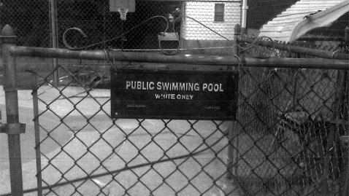Zero sum thinking leads to extraordinary outcomes in the real world that we are still paying the costs for from the 1930s and 1940s. The New Deal public good ethos helped to create the greatest middle class the world has ever seen, but everything created via the New Deal was exclusionary…for whites only.
* In the 1950s and 1960s, white people decided to drain their public swimming pools rather than integrate them, which resulted in the loss of a public good – not just for Black people, but for white people as well.
* The Civil Rights Movement resulted in the idea of “public good” becoming controversial once it included ALL of the public.
* Now, for the most diverse generation in history the ticket to the middle class is out of reach for them because they must get a degree, yet they are priced out of college.
* Why do we stand alone among industrialized nations in not guaranteeing that people can afford to see the doctor? Even though white folks are still the largest share of the uninsured, the majority are opposed to the modest support for the Affordable Care Act.
* Back in the early 2000s there was a flood of subprime loans in black and brown neighborhoods, where people already owned their homes, but they were marketed high interest rate, high fee, abusive mortgage refinances. Before the subprime lending crisis snowballed to take over the entire financial system, it could have been stopped when it was a clear and present danger, but only really for black and brown communities. The inaction of government ended up costing this country 8 million jobs and tens of trillions of dollars in lost homes and retirement savings. Homeownership rates still haven’t recovered over a decade later.
* We have been lied to so much about our history, and because we don’t have that shared history – because we have been robbed of our collective history – it’s very hard to move forward and really understand where the disparities come from. We need to have a real truth process that sets the history right about the ways that racism has played such an enormous role. We need to recognize that it’s in our collective self-interest to heal from these wounds and move away from the zero sum paradigm. Our country is not going to succeed if people of color don’t succeed. We need to refill the pool of public goods to make sure that we know on what ground we stand literally and figuratively, because this is really important to our economic future and economic health.

# **Panel Discussion**

Carol Mitchell moderated a panel, featuring Dr. Karen Johnson, Senator Nobles, AJ Gordon, Ali Modarres and Carlos Ortiz.

**Key takeaways**

* *The ultimate goal is to create an opportunity for each person to create a self-sufficient material foundation upon which to have a dignified, productive and creative life.* – Carol Mitchell
* *Top of mind for me is the solidarity dividend, because it reminds me of the term ‘synergy’, which simply states the whole is greater than the sum of its parts, which is what the solidarity dividend is all about –* Dr. Karen Johnson
* *If racism is rooted in othering fear, and a scarcity mindset costs everyone, imagine the prosperity, the health and well-being for everyone that solidarity brings when rooted in belonging. Love for humanity – or Ubuntu – an abundance mindset.* – Dr. Karen Johnson
* *We are all in this together, and if we are going to truly support Black businesses, we really must do it together*. *We all have to participate in creating a stronger Black-owned ecosystem. There is a real gap to accessing capital. Folks are guarding every penny, and the Black community is having a hard time gaining access to capital to launch and grow their businesses*. – Senator T’wina Nobles
* *Policy is also changing, and who is creating the policy is changing, so the rules of engagement will continue to change. Continue to step up. Elect leaders that you know are going to be supportive of Black-owned businesses and Black entrepreneurship. Make sure they are the key decision makers, so we can continue to see success.* – Senator T’wina Nobles
* *The Chamber started the BIPOC businesses accelerator. The County was able to leverage some funding, and through various partners and vendors, we are going to be giving grants to new businesses and existing businesses that are looking to grow. We have educational resources. We have different cohorts so we can have people that are together and flourishing. We don’t want any of our members to feel like they’re on this road alone. We’re all in this together.* – A.J. Gordon
* *Prior to the pandemic, we were on a downtrend globally – and also locally and nationally –with poverty rates. But in 2020, 11.4% more people feel into poverty in the U.S. (about 3.3 million individuals). The majority of people who lost their jobs were typically in service sector work, and typically, they were people of color, meaning the primary impact of the pandemic was on the very communities we have been talking about today*. – Ali Modarres
* *In Pierce County, our economy is highly dependent on the service sector and low wage earners, which means in 2020 we actually experienced something different*…*the dividends of not being equitable. What we really need to think about is employment with payments to equity, which means I should not be looking and King County and Pierce County data and notice that for the same jobs people are paid less here than they are paid up north. People commute to make up for the money that you don’t give them. What we are not paying attention to is that if wages are not made equitable in the region, we will be vulnerable to every epidemic and every economic episode we face. We need to invest in people. We need to understand that equity matters to everyone.* – Ali Modarres
* *You have to be very careful what you feed yourself…your mind, your body, your spirit and your soul. Whom you surround yourself with is extremely important. When I am creating film work or television documentaries, I always represent my community, my people and my neighborhood in a positive way. We’re not all gang members and drug lords. These are negative stereotypes we have been fed over the years. The Mayan people were artists, musicians, philosophers and mathematicians, and these are the stories that I want to bring to the world.* – Carlos Ortiz
* *If you don’t have a seat at the table, then build your own table. If you don’t see opportunities, then create those opportunities. The cavalry is not coming! Don’t ever let anybody tell you that you can’t achieve anything. Believe in yourself. Believe in your community. Believe in your people. Make a difference. –* Carlos Ortiz

# **Breakout Panels**

Participants selected one of three panel discussion breakout groups to attend. Following are summaries for each panel:

## **The Solidarity Dividend**

**Presenters: Marvin Kirkwood Vaughn and Amanda Walkingstick, Pierce County Community Engagement Taskforce Speaker’s Bureau *(this group brings community neighbors with lived experience in the system to the table and helps us figure out how to make the system better)***

**Facilitator: Mandy Lee, UWPC**

"Why Can't we have nice things?" is the opening line of Heather McGee's The Sum of Us. She further discusses that the "we" in this question is all of us-- all Americans. When it comes to creating change in the community, we must understand how we got here and how we are all impacted by systems built on racist policies. Two community members, Marvin Kirkwood and Amanda Walkingstick, shared their lived experiences to help all of us understand how and what we can do to make it better for all of us.

Marvin Kirkwood Vaughn's "typical" life story – filled with love, school, and sports – was turned upside down by significant events that devastated his family and changed his life forever. Heartbreak and a sense of desertion caused him to lose his way. He started hanging out on the streets, becoming addicted to meth. Eventually, he found himself homeless. But that is not the end of Marvin's story; his next chapter has already begun. Marvin shared his journey from despair and hopelessness to recovery and the promise of new beginnings.

Amanda Walkingstick navigated the dangers of living life on the streets from age fourteen to twenty. Homelessness was not the ideal option, but it provided the only safety she could find. Broken and worn down, Amanda and her dog were taken off the streets and adopted by a pair of sisters. Amanda slowly began to change into the person she always knew she could be with their love and guidance. Pursuing a burning desire to help others like her, Amanda went back to school and completed her High School education. She is currently pursuing a degree in Human Services to help those living in homelessness and struggling with mental health challenges.

## **Prospering Together: Local Strategies that Benefit All of Us**

**Presenters: Kate Condit, CEO, Workforce Central; Drea Baines, CEO, Impossible Consulting; and Betty Capesteny, Director of Economic Development for Pierce County**

**Facilitator: Dona Ponepinto, UWPC**

This session took a deeper look at how the local systems and structures are addressing racial equity to bolster economic growth. The presenters engaged in a dialogue on how their organizations are creating strategies to address the inequities and disparities in workforce development for Black, Latino and Indigenous people and the efforts being made to remove barriers to opportunities so that we all prosper in Pierce County.

Some of the key take aways:

* Things like making lived experience as or more important in our hiring processes as education and credentialing, for example. Making sure that everyone who enters our organization has the same amount of time off allotted from day one, regardless of hierarchy or role.
* Trust and understand that people facing barriers to employment know what they need. So, it is our job to fund that, to trust that and to listen that. Therefore, we have shifted our contracting processes to make it a lot easier for local community-based organizations to access our funds.
* Key is to find ways to help communities of color with entrepreneurship and wealth building, but can’t do it in a vacuum. Need to work with partners in those communities such as KWA, APCC, Tacoma Urban League and others.
* How do we ensure economic equity, when communities of colors might not have access to resources? How do you get rid of all of the “hoops”?
* The Pierce County Accelerator concept that came out of the Chamber and County Economic Development provides space for training and access to resources and is a concept that is unique to the county. While not perfect, it is an intentional first step in creating opportunities for BIPOC communities to get access to supports and capital.
* “It’s access to capital”! It is the number 1 barrier and the Accelerator concept provides an opportunity to begin to remove those barriers.

At the end of the day we are all together in this and working together and listening to our communities about how we can prosper and really grow the pie for everyone. As Heather mentioned, all our efforts should be towards making a difference and leaving a legacy for the future that is different from our past legacies.

We should continue to hold the mirror up, hold the mirror up to the systems, the power and the privilege and the shifts that we can make within, whether it is within the county or workforce development entities, that internal change matters greatly.

Less talk, more walk. Learn from the assumptions we make and figuring out ways we can work better together, get rid of those assumptions, pay attention to what the community is saying and what the needs are, and holding our city/county governments accountable for ensuring more equitable practices and providing those opportunities.

## **Growing Resilience Through a Guaranteed Income**

**Presenters: Mayor Victoria Woodards, City of Tacoma; Rep. Liz Berry, 36th Legislative District; and Megan Matthews, Engagement Manager for Poverty Reduction, DSHS**

**Facilitator: Abigail Lawson, UWPC**

Mayor Victoria Woodards is a member of Mayors for a Guaranteed Income and brought a 12 month guaranteed income research demonstration, administered by United Way of Pierce County, to the City of Tacoma that will provide $500 a month to 110 families.

Representative Berry put forward a statewide guaranteed income bill and budget proviso during the 2022 legislative session.

Megan Matthews is a key member of Washington’s 10-year Poverty Reduction team that is currently running a statewide guaranteed income feasibility study.

Key takeaways from the discussion:

* Poverty is complex and must be addressed comprehensively and if our government had the solution then we wouldn’t be in this situation. Our government must get comfortable with sharing power. – Megan Matthews
* There is a shared desire to fundamentally change the way our public benefit system is structured. So, we need to approach things in a different way and a major part of that is partnering with communities to design programs that work for them - Megan Matthews
* Guaranteed income aligns with two separate strategies on Washington state’s 10-year Poverty Reduction Plan - Megan Matthews
* Ultimately, guaranteed income will work best as a federal program, but by starting on the local level there is an opportunity to generate support, understanding, and data to show how and why it works. - Mayor Victoria Woodards
* Why a guaranteed income in Tacoma? It fits perfectly as another piece of the puzzle that United Way of Pierce County and the City of Tacoma are trying to put together in an effort to support families in moving out of poverty and into self-sufficiency. - Mayor Victoria Woodards
* Guaranteed income is an innovative solution and sometimes innovations of this caliber can be halted by an unwillingness to try something new, but we didn’t want that to be the case here in Tacoma - Mayor Victoria Woodards
* We know direct cash assistance works, so the effort now has to be around education. Educating ourselves and our policymakers will be the biggest hurdle in the mission for a basic income - Representative Berry
* You can tell the values of a government based on its budget and its policies - Megan Matthews
* People understand that our system has been built on inequity and we want to address that. One of these inequities is the economic value or lack thereof, that is associated with stay-at-home caregivers. We want to be valuing the labor of caregivers and we want people to have power and control over their lives to decide what is right for them in their families. Do we want people in the workforce because that’s what's typically financially valued? On the other hand, do we want them to be empowered and able to make choices for the betterment of themselves, their families, and their communities? - Megan Matthews
* When people have a little bit more money in their pocket that they can use to feed their families and keep a roof over their heads they're not running out and having to take jobs that don't suit them or their families. They are able to be a little choosy about what kind of job they want, they're able to bargain for higher wages and better benefits and their families are able to afford childcare. - Representative Berry
* Once we figure out the values and desired outcomes, the path forward will become clear. - Megan Matthews
* There are people who get up and go to work every day, and sometimes work more than one job, but still don't have enough money to take care of their basic needs. Therefore, we want to provide a face for our families in order to break the stigma around poverty. People do not wake up and choose to be poor - Mayor Victoria Woodards
* Basic income is one tool in the toolbox, but a tool that we need to address income inequality and wealth, the wealth gap, and inequity in general - Megan Matthews
* Educate yourself, educate those around you and continue to be really strong advocates for programs like this. We can’t do it alone. We need all of you to help us – Mayor Victoria Woodards

# **Hopeful Words**

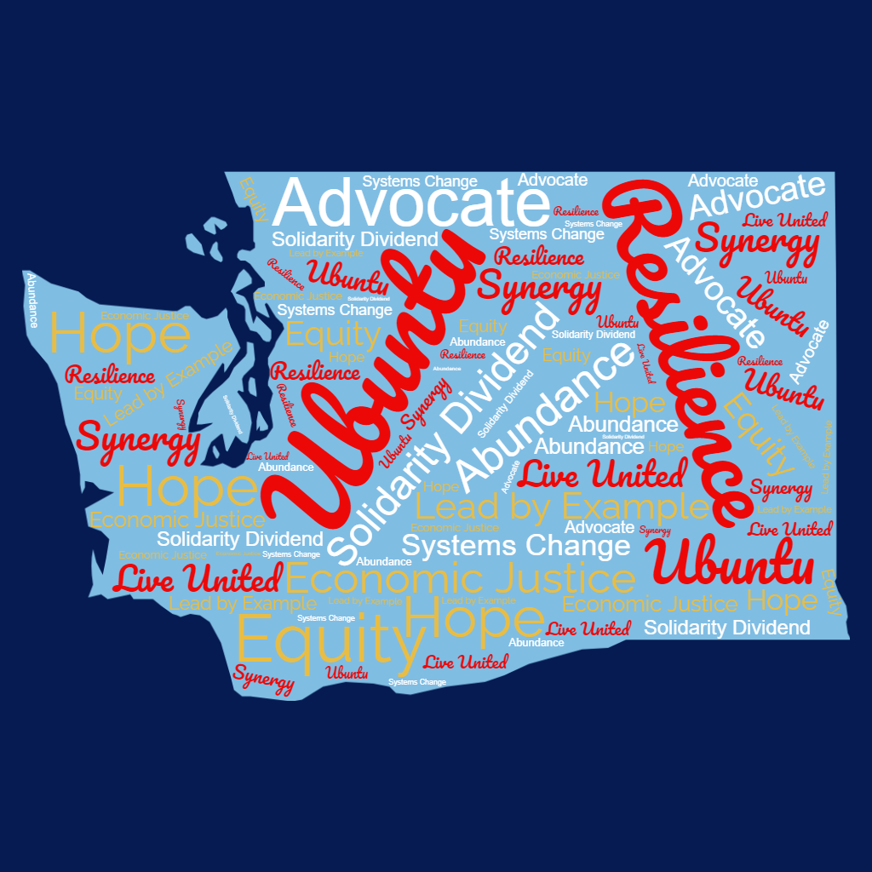

### **We are all challenged here today to go upstream, beyond designing programs, to disrupting systems – and fundamentally disrupting structural racism. Thank you to those that were able to attend our annual Poverty to Possibilities event. We could not have done this without the support of our generous sponsors, our thought partners, and you.**

Breakout Session Takeaways

*Select quotes from Poverty to Possibilities*

# **Lived Experiences**

“We have a lot of work to do Not many minorities at my workplace. Participate in these events. When a black worker speaks, others do not believe it’s true. When white co-workers hear messages from others, this is a serious issue. It will open the eyes of others. We’re in this together. If we work together, we can eliminate barriers. “

“As a person of color, so many things are not geared for my success.”

“I grew up in the military in a biracial family. The swimming pools were not as much of an issue in the military. However, in public we did run into those things. My mom could go places because she is white.”

“Poverty is a policy choice - service workers, BIPOC, women, and folks without a HS education were impacted the most during the pandemic. Big push to support Black owned businesses, but it didn't last.”

# **Perspectives on *The Sum of Us***

“There’s a lack of reference to the past and how we go here. As nonprofits, we often work with the zero sum thinking. A lack of resources makes us think like this.”

“This makes me think of all of the opportunities that our country has missed because of zero sum thinking and actions. How many diseases would be eradicated? How many inventions did not emerge?”

“Those who have already read the book felt it was very powerful and spelled out how economics doesn’t have to be like it is now. Presented a strong argument for change. The numbers don’t lie. Several participants are in book groups with the Sum of Us right now.”

“Filling those pools hurt everyone and that it how the zero sum thinking hurts us all.”

“We aren’t doing enough to help people access home ownership, especially in BIPOC communities / we need affordable housing for all.”

“The Lie we are told is that there is a Hierarchy of Human Value”

“Understanding that we do NOT live in scarcity is essential and not widely thought.”

# **Working towards solidarity**

“How can we fight apathy when voting? We’ve bought into Zero Sum Game (what I do doesn’t matter). We’re working hard. There are enough of us to make a difference in ending poverty.”

“Acknowledge there are many systems leaders in this audience and that we cannot design for people without the people we are designing for being in the room. We cannot continue to do as we have in the past and make decisions about what communities need without their input. Who is not at the table? Emphasis on the need for a mindset shift starting with internal processes.”

“Nothing about us without us. Cross section for Community is essential. United Way reaching out is an ideal for community outreach.”

“During the summer, there is limited time for the resources and funneling those in to the system. We need inter relational work with schools and resources. Would like to see this happen. Need help pairing resources.”

“Need to diversify existing leadership structures…”

“Feel like what we are doing now is a start. Our job is to continue, to go out there and spread the word.”

“Many historical disadvantages come from artificially or mentally creating scarcity. As nonprofits, how do we become more open source with resources? How do we truly collaborate, especially when it’s about the other organization and not about us? How do we not only ensure our organizations are successful in obtaining funding and serving clients, but how can we help others secure funds and partner in their work. That’s the solidarity piece I drew from this.”

“Collaborate more, Collaboration is the new inclusion. Leverage the relationships formed in venues like that and expand. Focus on reducing redundancies. Find who is working on an issue and what is working and build on that. It’s not about ownership of ideas, its learning what is working and leveraging that knowledge to expand impact.”

“Banks and credit unions aren’t offering products that Black business owners need. One member reached out to see what his credit union could do to help with this. All of us- the challenge of poverty isn’t one groups problem, it’s something we all need to pull together.”

“Advocacy! Lift up voices. Tell stories. Share.”