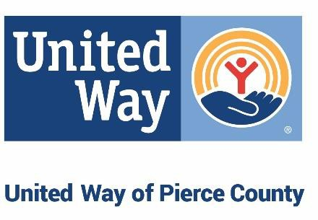

Community Investment Request for Proposals **EQUITY FUND**

*Guidelines and Strategies for the 2025-2027 Community Investment Cycle*

# Together, we will lift 15,000 households out of poverty by 2028

Applications are due by September 30, 2024

REQUEST FOR PROPOSALS

United Way of Pierce County (UWPC) supports partnerships that stabilize households and break down barriers to self- sufficiency. UWPC’s community investments are focused on achieving our bold goal of helping to move 15,000 households out of poverty and into self-sufficiency by 2028. Investments are also focused on achieving a just, equitable, and inclusive Pierce County community where everyone has access to opportunities and the resources needed to thrive and achieve their greatest potential.

For the 2025-2027 Community Investment Cycle, we will be investing intentionally for impact that aligns with our vision for equity by focusing specifically on ten (10) communities rated as low equity on the Pierce County Equity Index as well as communities with the highest percentages of ALICE which reflect disparities in the distribution of wealth in our community. Additionally, UWPC will be investing the highest amounts for the most impactful partnerships and **expanding access to funding for grassroots organizations that are innovating and engaged in capacity building.**

GOALS FOR THE HOUSEHOLDS WE SERVE:

* Every Pierce County household can achieve self-sufficiency
  + Community members have safe, adequate, and affordable housing
  + Families and individuals can provide all the essentials of daily living GOALS FOR OUR NETWORK:
* An interconnected system of partners working on the most pressing challenges with a common agenda
* Mutual awareness of initiatives to reduce redundancies in navigation and increase access to services
* Shared data that drives best practices while centering lived experiences of poverty in our community
* Changes in systems and neighborhood conditions for a more just and equitable community

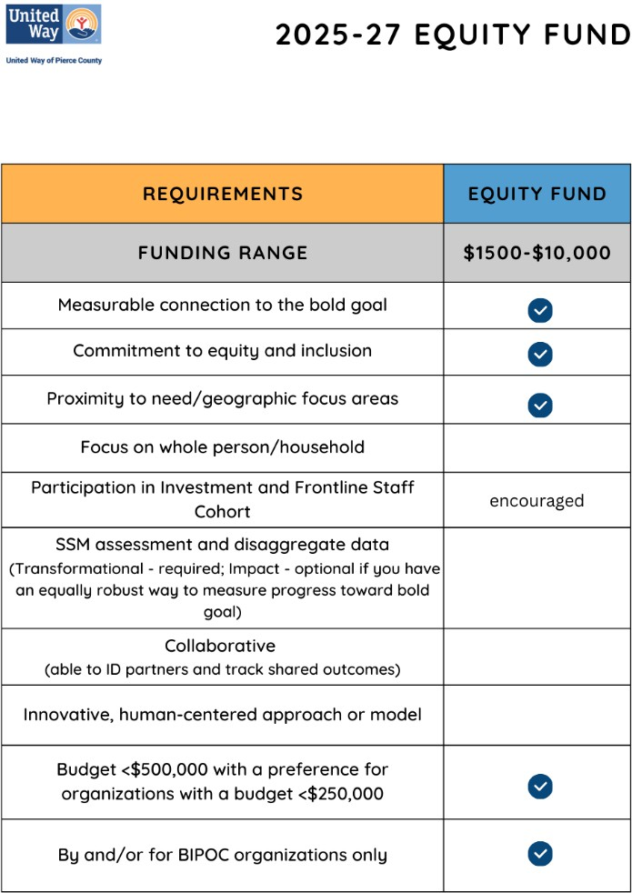

# EQUITY FUND

Black, Indigenous, and People of Color (BIPOC)-led and serving nonprofits encounter serious barriers due to limited funding, inadequate infrastructure, and years of underinvestment. The Equity Fund is designed to support under- resourced, grassroots organizations led by and serving BIPOC communities by investing unrestricted funding using a process leaning into trust-based philanthropy principles. UWPC will employ the following criteria when determining eligibility for the Equity Fund:

* Staff and board leadership are majority BIPOC (>50%);
* Serving majority BIPOC communities (>50%);
* Physically provides services in communities where significant populations of BIPOC households reside;
* Annual operating budget of no more than $500,000, with a preference for those at less than $250,000;
* Founded or evolved to serve the needs of communities of color; and
* Measurable connection to UWPC’s bold goal of moving households toward self-sufficiency

### Can an organization apply for funds more than once during this grant cycle?

The Equity Fund awards one-year grants. An organization or group can only receive one grant award each year (12 months). However, an organization that received an award in January 2025, for instance, could apply again and receive another award in January 2026 or 2027. Additionally, this fund will award grants at two points each year, in January and July. An organization that applies for an award in the January award cycle but does not receive an award will have its application automatically carried over and be considered for the July award cycle.

## Application Submission

The Equity Fund application will remain open throughout the 2025-2027 investment cycle, with application review occurring twice annually. **Following is the investment review schedule:**

### EQUITY FUND APPLICATION SUBMISSION TIMELINE

|  |  |  |
| --- | --- | --- |
| **Investment Cycle** | **Award Announced** | **Award Timeline** |
| Aug 1 – Oct 31, 2024 | Dec 2024 | Jan 1 – Dec 31, 2025 |
| Jan 1 – Apr 30, 2025 | Jun 2025 | July 1, 2025 – June 30, 2026 |
| Aug 1 – Oct 31, 2025 | Dec 2025 | Jan 1 – Dec 31, 2026 |
| Jan 1 – Apr 30, 2026 | Jun 2026 | July 1, 2026 – June 30, 2027 |
| Aug 1 – Oct 31, 2026 | Dec 2026 | Jan 1 – Dec 31, 2027 |

**Proposals must be received by UWPC, through the online application system, on or before 5:00 pm PST on Sept 30 for a January 1 award and March 31 for a July 1 award.** Complete application requirements and access to the online application systems are available on our website at <https://www.uwpc.org/community-impact-equity-fund>

## Requirements for Funding

To qualify for United Way of Pierce County funding, organizations must:

1. Qualify as a nonprofit organization with 501(c)(3) status or have a verifiable 501(c)(3) fiscal agent
2. Programs or services must operate within Pierce County boundaries
3. Have the capacity to advance the goals of UWPC as described in the RFP

## Grant Terms

Equity Fund grants are for a term of one year. Applicants may apply more than once, but may not apply more than once within a twelve month period.

## Grant Conditions

United Way funding is based on the premise that partnership and collaboration are the cornerstones of our effort to create lasting change in our community. United Way recognizes the rights and authority of organizations, through their governing bodies, to determine their own policies and manage their programs. In that spirit, United Way delineates the following grant conditions to be acknowledged by grantees as part of their obligation upon acceptance of investment funding:

1. Communicate in writing to UWPC’s Community Impact team, as early as possible, whenever changes – which might affect the organization’s or program’s ability to deliver the results outlined in its proposal – have occurred, including changes in key staff.

## Financial Reporting

We expect investment recipients to be able to produce line-item budget to actual reports covering the most recently completed fiscal year.

## Reporting Requirements

The following reporting requirements will be part of the investment partner’s obligations upon acceptance of grant

funding:

* + **Periodic check-ins within the one-year grant timeframe**

## Community Impact Staff Contacts

The Community Impact Team is responsible for UWPC’s Community Investment process. Technical assistance is available for anyone in need of support with outcome measures, evaluation, and other questions. Please reach out to clarify alignment, if you are unsure about whether or not a program or service fits within our focus areas.

|  |  |  |  |
| --- | --- | --- | --- |
| **Name** | **Title** | **Phone** | **Email** |
| Kelvin (KC) Ceasar | Sr. Manager, Policy and Community Engagement | (253) 597-4257 | [kelvinc@uwpc.org](mailto:kelvinc@uwpc.org) |
| Leah Martin | Impact & Engagement Coordinator | (253) 682-1810 | [leahm@uwpc.org](mailto:leahm@uwpc.org) |