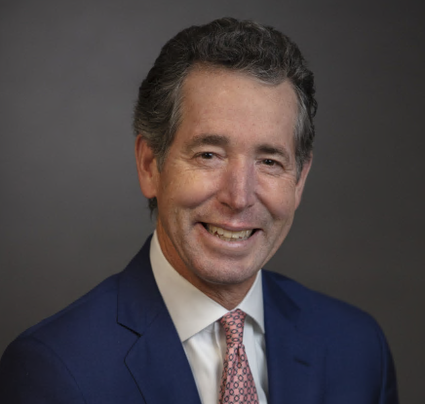**Steve Harlow**

**Senior Vice President and Private Client Advisor,**

**Bank of America Private Bank**

Steve Harlow is a Senior Vice President and Private Client Advisor with Bank of America Private Bank in Tacoma, Washington. For more than 30 years, he has leveraged his wealth of experience to provide personalized banking solutions to his clients in the South Puget Sound and beyond.

Steve puts a premium on frequent communication with clients designed to inform and educate. In offering focused attention, he and his dedicated team provide private banking, intergenerational wealth planning, cash flow planning, disciplined investment management, business transition planning, philanthropic guidance, and access to customized lending solutions.

An active listener and responsive problem solver, Steve finds it fulfilling to help individuals, families and endowments address their financial challenges and explore opportunities.

Steve received a B.B.A. from the University of Texas at Austin and serves on the boards of the United Way of Pierce County and Trauma Trust. He is also a member of the Tacoma Estate Planning Council, Washington Planned Giving Council, and the American Leadership Forum – Tacoma/Pierce County Chapter (Class XVIII). Previously, Steve served on the boards of the Tacoma Art Museum, Tacoma Country & Golf Club, Pacific Northwest Ballet and Tacoma-Pierce County Chamber.

**Bruce Dammeier**

**Pierce County Executive**

Bruce holds the office of the Executive of Pierce County. He served on the State Senate for three years, the House of Representatives for four years and was a member of the Puyallup School Board for eight years. He is also a small business owner and director of printing business in Pierce County Bruce grew up in University Place, graduating from Curtis High School. He went on to graduate with distinction from the U.S. Naval Academy with a degree in engineering. He served for eight years in the Navy, stationed throughout the world, including the Bangor Submarine Base and earned his Masters in Engineering from the University of Washington.

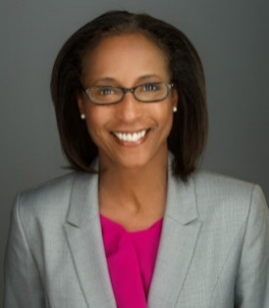**Dona Ponepinto**

**President and CEO, United Way of Pierce County**

Dona has been the President and CEO for United Way of Pierce County since 2014 and has been with the United Way movement for more than 30 years. Locally she led a groundbreaking tristate research project on the financial stability of families, deployed navigation specialists for South Sound 2-1-1, launched seven Center for Strong Families sites and serves on the Governor’s Poverty Work Group.

Dona holds a BA in Psychology and a Masters in Counseling with an emphasis in children and families from Creighton University.

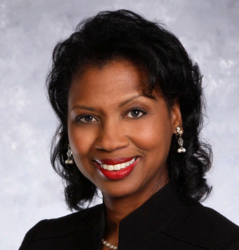**Carol C. Mitchell, J.D.**

**Founder, Institute for Black Justice**

Carol C. Mitchell holds a Juris Doctor from Seattle University School of Law, a Master of Arts in Organizational Systems Renewal from Seattle University, and a Bachelor of Arts in Sociology from the University of Washington Seattle. She founded the Institute for Black Justice (IBJ) in September 2020. The purpose of the IBJ is to relentlessly pursue equity and justice for all.

Mitchell has more than 20 years of public sector leadership experience, having served most recently in Pierce County, Washington. Her primary responsibility was to improve outcomes for individuals with behavioral health and substance use conditions who were caught in the grip of the criminal justice system. She has significant organizational and human resources experience, having served as the Chief HR Officer for the Port of Tacoma, Chief Organizational Development and HR Officer for Metro Parks, Public Relations Officer for Pierce Transit, and as Executive Consultant for her own preventive law firm.

Mitchell spent 17 years as the host of TV Tacoma's "CityLine," a public affairs talk show. Her volunteer activities include an appointment to the Board of Trustees of Clover Park Technical College, Past President of the Fair Housing Center of Washington Board, past member of the Palmer Scholars Board of Directors, and Past President of the Tacoma City Association of Colored Women's Clubs, Inc.

She is proud to be in service to her community, to her soon-to-be-85-year-old mother, her 3 adult children and her 6 grandchildren.



**T'wina Nobles**

**President & CEO, Tacoma Urban League**

T’wina is senator for the 28th Legislative District of Washington state. She also serves as the president and CEO of the Tacoma Urban League, where she leads programs to strengthen and support the local African American community in social equality and economic independence.

Growing up, T’wina and her family faced many challenges, including homelessness, which led T’wina to move into foster care at the age of 15. T’wina was determined not to become a statistic, and applied her passion, energy, and hard work to graduate high school and go on to become an educator.

Education has always been central to T’wina’s life, and she believes strongly in giving back to the community that helped her succeed. Previously, T’wina worked as an instructor for Metropolitan Development Council’s College Bound program at Stadium High School and Lincoln High School in Tacoma, as well as served as a PTA leader and a school board member. She also co-founded Ladies First, an in-school and after-school program dedicated to empowering young women and building positive self-esteem. She attended the University of Puget Sound, where she earned her undergraduate degree and a Master of Arts in Teaching.

T’wina, her husband and children, live in Pierce County. In her free time, T’wina enjoys lazy days with family, running environmental justice camps for her mentorship group, outdoor adventures in our state parks, and reading inspirational nonfiction.

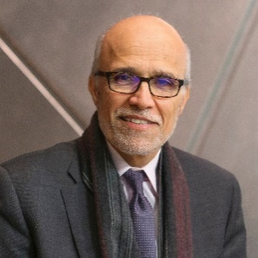**Dr. Ali Modarres**

**Dean, School of Urban Studies, Assistant Chancellor for Community Partnerships at University of Washington Tacoma**

Ali is the Dean, School of Urban Studies, Assistant Chancellor for Community Partnerships at University of Washington Tacoma. For eight years, he served as the Editor-in-Chief of Cities: The International Journal of Urban Policy and Planning. He earned his Ph.D. in geography from the University of Arizona and holds masters and bachelor’s degrees in landscape architecture from the same institution. He has published in the areas of social geography, immigration, urban development, planning, and policy. A significant portion of his public scholarship focuses on economic development through an equity lens.

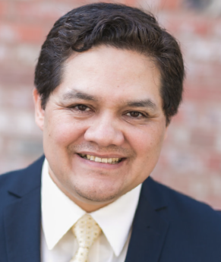**Carlos A. Ortiz**

**Writer, Director, Producer**

Born and raised in East Los Angeles, California, (GO East Los!), but currently living, working and playing in Tacoma, Washington (The City of Destiny). Carlos, with Zeta-Maya Entertainment, is an experienced, unique and passionate independent filmmaker who knows about adversity and how to use education, storytelling and the power of positive thinking to overcome any obstacle, problem or challenge in life, as well as in the film business. He’s an exciting, new voice for the Latino community, and as a family man, filmmaker, community leader, educator, and mentor, he devotes his time to helping others achieve success in order to make a positive difference and make our world a better place as a way to leave a lasting legacy.

His focus as a Writer/Director/Producer is on narrative feature films, feature length documentaries, and original TV series that are in some way groundbreaking, inspirational, educational, entertaining, and that tell timeless stories that are universal in their appeal. His films explore the darker side of the human condition as a way to shed some light on controversial topics, current issues, and hopefully start a dialogue in order to find solutions to the many challenges and problems we face as humans.

He has written, produced, and directed several short films, TV commercials, music videos, and documentaries. He has studied photography and liberal arts at East Los Angeles College, film at UC Berkeley under 4-time Academy and Oscar® Award winning sound designer Mark Berger, best known for his work on The Godfather II, Apocalypse Now and Amadeus. He also studied videography at Clover Park Technical College and worked with 4-time Emmy® Award-winning videographer and editor Scott Blatman, best known for his work on Bill Nye The Science Guy, broadcast TV and King 5 News, and has sat on the panel of judges for the Emmy® Awards.

Carlos is a marketing guru, the Co-founder and Chairman of LUNA, an education based, charitable nonprofit helping underprivileged and under-represented youth pursue and attain a professional career, who has over 20 years of photography and video production experience, over 15 years of sales and business development experience, and over 10 years of marketing and advertising experience. He is passionate about working with the whole community, improving the lives of his fellow Latinos and others, and creating opportunity for the underprivileged, especially our youth. He plans to be one of the greatest filmmakers in the history of cinema.

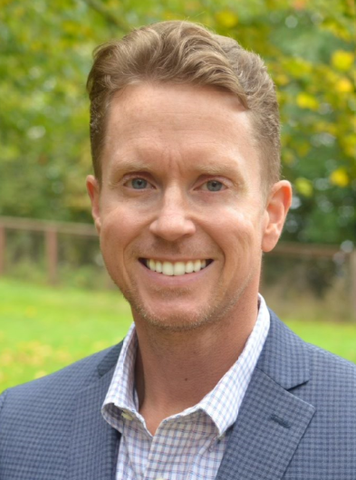**AJ GORDON**

**Vice President, Senior Relationship Manager, Banner Bank’s South Sound Commercial Banking Division**

AJ Gordon is the Vice President, Senior Relationship Manager for Banner Bank’s South Sound Commercial Banking Division. Additionally, he serves on the Tacoma-Pierce County Chamber of Commerce’s Board of Directors as Board Chairman, the Tacoma-Pierce County Business Alliance PAC Board of Directors as Board Chairman, the Information Technology Cluster Strikeforce for the Economic Development Board of Tacoma-Pierce County, and was recently appointed as an Honorary Commander at McChord Air Force Base.

AJ is the founding Charter President of the Rotary Club of Tacoma Sunset, and continues to maintain an active role in his club’s activities. Previous community involvement includes Past Chairman of the Board for the American Red Cross, and co-founding Board Member and Past Board Chair for the Young Professional Network of Tacoma-Pierce County.

A native to the South Sound, AJ and his wife and 3 kids live in Brown’s Point, WA.

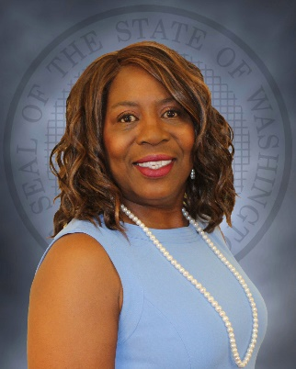**Karen A Johnson, PHD**

**Director, Washington State Office of Equity**

Dr. Karen A. Johnson,goes by Dr. J,is the inaugural Director for the newly created Washington State Office of Equity, established by the legislature and signed into law in April 2020.

The office will work with agencies to increase access to equitable opportunities in order to bridge opportunity gaps and reduce disparities. The office will also work with communities to develop the state’s five-year equity plan.

An inspiring, authentic, servant leader with decades of experience in both managerial and leadership roles in the non-profit sector and in federal and state government, Dr. J is energized by helping others excel.

She lives her legacy by unapologetically championing and challenging others to embrace, emulate, and embed a culture where everyone commits to collectively value, include, hear, and respect each other so that individual and organizational excellence is realized.

She volunteers her time with people, places, and purposes focused on children, environmental justice, and underserved populations. A few examples of her current and former board service include the South Sound YMCA, Thurston Climate Action Team, the Making a Difference Foundation, Black Alliance of Thurston County, and the YWCA of Olympia.

She holds a bachelor’s degree in occupational therapy, a master’s in public administration, and doctorate in Urban Services. She is also a member of the 2018 Leadership Women America cohort.

Dr. J says, “I will work toward equity and justice for all… until justice rolls down as waters.”

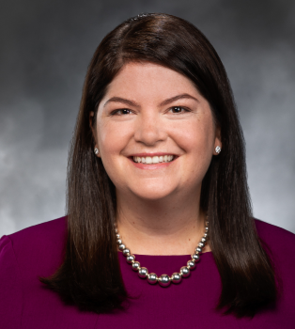**Representative Liz Berry**

**Washington State Representative for the 36th Legislative District**

State Representative Liz Berry was elected to serve the 36th Legislative District in November 2020. She serves as Vice Chair of the Labor & Workplace Standards Committee and is a member of the Environment & Energy and Transportation committees, where she is a passionate advocate for working families and combating climate change. Liz previously led the Washington State Association for Justice; the region’s largest civil justice advocacy organization dedicated to standing up for the legal rights of patients, consumers and injured workers. For four years, Liz worked for U.S. Representative Gabby Giffords, lastly as her Legislative Director.

Liz is also the proud Co-Chair of the House Democratic Moms’ Caucus, which aims to uplift our state’s families, and children through priorities like direct cash assistance. Last year, Liz secured a $200 million investment to expand access to Washington’s historic Paid Family Medical Leave program. She is working on guaranteed basic income legislation to be introduced in the 2022 session. Liz lives with her husband Michael and their two children, George (5) and Eleanor (2) in Queen Anne.

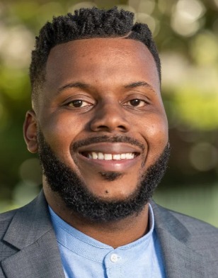**Michael D. Tubbs**

**Founder / Executive Chairman of Mayors for a Guaranteed Income**

**Founder / Executive Director of Ending Poverty in California**

**Special Advisor to Governor Newsom (CA) on Economic Mobility and Opportunity**

**Former Mayor City of Stockton**

Michael Tubbs is the Special Advisor to California Governor Gavin Newsom for Economic Mobility and the Founder and Chair of Mayors for a Guaranteed Income.  He was elected Mayor of Stockton in 2016 at 26 years old. He was Stockton’s first African-American Mayor, and the youngest Mayor of any major city in American history. As Mayor, Tubbs was lauded for his leadership and innovation. He raised over $20 million dollars to create the Stockton Scholars, a universal scholarship and mentorship program for Stockton students. Additionally, he piloted the first mayor-led guaranteed income pilot in the country.

Under his leadership, Stockton was named an “All-America City” in 2017 and 2018; saw a 40% drop in homicides in 2018 and 2019; led the state of California in the decline of officer involved shootings in 2019; was named the second most fiscally healthy city in California and one of the top most fiscally healthy cities in the nation and was featured in an HBO documentary film “Stockton on My Mind.”

Tubbs has been named a fellow at the Harvard Institute of Politics and The MIT Media Lab, a member of Fortune’s Top 40 under 40,  a Forbes 30 under 30 All-star Alumni, the “Most Valuable Mayor” by *The Nation*, the 2021 Civic Leadership Award winner from The King Center, and 2019 New Frontier Award Winner from the JFK Library.  Previous to serving as Mayor, Tubbs served as a Councilmember for the City of Stockton District 6, a high school educator, and a fellow for the Stanford Design School and the Emerson Collective.

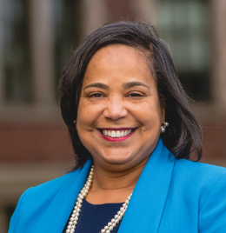**Mayor Victoria Woodards**

**Mayor, City of Tacoma**

Mayor Woodards was elected as mayor in 2017 and her term expires in 2021. She formerly served on the city council for two terms. A former member of the board of Metro Parks Tacoma, she has also served as president of the Tacoma Urban League. Woodards grew up in Tacoma, attended Lincoln High School and was later stationed at Fort Lewis while serving in the U.S. Army. Her key areas of focus include family-wage jobs, public safety, responsible budgets, local businesses and a lasting solution to homelessness and mental health crisis.

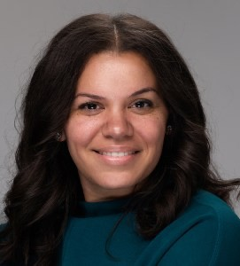**Drea Baines**

**Founding CEO of IMPOSSIBLE Consulting**

Drea is abusiness consultant dedicated to the economic equity and empowerment of Afro-Americans.

Since 2010, Drea has strategized and developed plans for start-ups and growing enterprises. As the conversation, surrounding the racial wealth gap reaches fever Black-owned enterprises seeking resources and capital.

Drea is now the Founding CEO of **IM**POSSIBLE Consulting, a firm that prioritizes Black founders and entrepreneurs for business development and funding assistance. She is also the VP of her and her husband, Jessie’s, latest venture the National Assoc. of Black Entrepreneurs (NABE). Their experience in the private, public and nonprofit sectors drove their shared vision for an entity that could intersect community, economy, and policy on behalf of black contractors and tradesmen.

Drea has worked with notable institutions as well as dynamic small businesses throughout the Puget Sound area. Advocacy is always at the heart of her efforts and has long been sustained through various community partnerships and projects. Drea’s portfolio consists of 96% Black-owned businesses, which she has paired with larger private/public entities to ensure that each client is connected to, and supported by, a robust economy. Some of her most notable collaborations include Craft3, the Tacoma Pierce County Chamber, and the Tacoma Housing Authority.

Drea currently serves on the Board of the Pleneurethics Society to empower students seeking higher education. She is also an American Leadership Forum Fellow, Class 28. She has served on the Board of Directors for Y.W.C.A. Pierce County, Tabor 100, Network of Women, and Good Shepherd Youth Outreach. In 2018, South Sound Magazine named Drea one of Puget Sound’s Top 40 Under 40 business leaders. She has spoken at Seattle Central College, the University of Washington, and various business and community events throughout the area.

Drea is the wife of Tacoma Metro Parks Commissioner and CEO of HULK Construction, Jessie Baines. Outside of work, she enjoys spending time with loved ones, learning new things, being outdoors, and having adventures with their son.

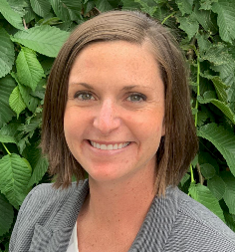**Katie Condit**

**CEO, WorkForce Central**

Condit is the CEO for WorkForce Central, Pierce County’s workforce development board. WorkForce Central bridges the gap between employers and workers through coaching, training, job placement and retention support with the aim of building and sustaining a robust talent pipeline into living wage jobs.

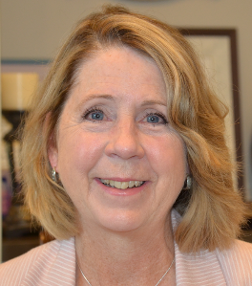**Betty Capestany**

**Director of Economic Development, Pierce County**

Betty Capestany serves as the Director of Economic Development for Pierce County. Her department focuses on retaining, growing and bringing new jobs to Pierce County. Last year, they delivered $46.5M of CARES funding to small businesses in Pierce County. Currently she is overseeing $40 million dollars of American Rescue Plan economic stabilization and recovery funds to help Pierce County businesses receive resources during the pandemic. One of those programs include the Pierce County Accelerator. The Accelerator is an entrepreneurial program that is focused on BIPOC start-up and Micro businesses.

Betty’s career has focused on building communities with the knowledge that successful, supported businesses help a community thrive. Prior to coming to Pierce County Betty served as CEO of the Bellevue Chamber of Commerce for 17 years; and prior to that the City of Renton Economic Development Director, Renton Chamber of Commerce CEO and Assistant Director for the Kent Chamber of Commerce. Betty and her husband George have a blended family of 4 boys, two loveable labs and 2 blackberry-eating goats.

**Amanda Walkingstic  
Co-leader, The People’s Group in the Pierce County**

From age fourteen to twenty Amanda Walkingstick navigated the dangers of living life on the streets. Homelessness was not the ideal option but provided the only safety she could find. Broken and worn down, Amanda and her dog were taken off the streets and adopted by a pair of sisters. With their love and guidance, Amanda slowly began to change into the person she always knew she could be.

Today Amanda is married with two kids and the same dog that got her through the most trying times of her life. Pursuing a burning desire to help others like her, Amanda went back to school and completed her High School education. She is currently pursuing a degree in Human Services, is a co-leader for the People’s Group in the Pierce County Community Engagement Task Force and has been accepted into the National Honors Society.

Amanda plans to continue her education with a focus on Psychology. Her dream is to use her experience and education to help those living in homelessness and struggling with mental health challenges. Amanda is working towards creating her own non-profit that uses some of the holistic approaches that helped her grow.

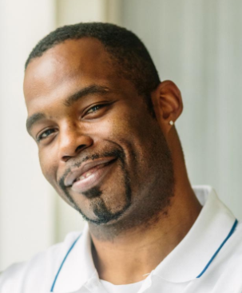**Marvin Vaughn**

**Pierce County Community Engagement Task Force**

Marvin Kirkwood Vaughn’s “typical” life story – filled with love, school, and sports – was turned upside down by major events that devastated his family and changed his life forever. Heartbreak and a sense of desertion caused him to lose his way. He started hanging out on the streets and he became addicted to meth. Eventually, he found himself homeless. That is not the end of Marvin’s story; his next chapter has already begun. Marvin will share his journey that went from despair and hopelessness to recovery and the promise of new beginnings.

**Mandy Lee**

**Director of Family Stability Initiatives, United Way of Pierce County**

Mandy Lee has always had a passion for creating equitable communities that disrupt poverty. She first began to understand structural inequity with her job as an admin for the Disability Resource Center in college, where she learned about accessibility disparities in higher education. She continued in various positions in nonprofits and as an entrepreneur, before joining the United Way Team in Colorado where she focused on building nonprofit capacity through community impact work and volunteer engagement.

Looking to bring her family to a more diverse and inclusive community in the Pacific Northwest, Mandy was thrilled at the opportunity to become the Director of Family Stability Initiatives at United Way of Pierce County. In this role, she provides leadership to the Centers for Strong Families and it's mission to help families achieve long-term economic stability through employment and financial coaching and income support counseling. She works towards building a cross-sector group of diverse stakeholders, that includes and centers the needs of people with lived experience, will achieve results that disrupt poverty for all Pierce County residents.

Mandy looks forward to reuniting her family in Tacoma, where she and her husband spent their honeymoon and every anniversary since

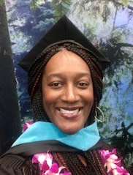**Megan Matthews, MPA, CDE, CDP, Prosci® CM**

**Engagement Manager, Washington State Department of Social and Health Services**

Megan Matthews is the Engagement Manager for the Department of Health and Human Services, supporting the Governor’s work for a just and equitable WA to significantly reduce poverty and inequality in Washington State. She also works with the City of Olympia, advising the development of their first Social Justice Commission. Megan also teaches the Masters’ Program at The Evergreen State College, influencing a cohort of public administrators to think critically and pursue actions with equity in mind. She is committed to pursuing and living the values of equity and justice.

Megan earned her Master's Degree in Public Administration from The Evergreen State College. She is certified as a Prosci® Change Management Practitioner, a Diversity Professional (CDP) and as a Diversity Executive (CDE). Megan is the past chair for BUILD, Washington State's first Black Community Business Resource Group. She is passionate about social justice and ensuring fairness for everyone, especially the next generation that includes her three-year old and 8 month old daughters and nieces and nephews.

**Chris Surface**

**Managing Artistic Director, Tacoma Little Theatre**

Chris was raised in the Pacific Northwest (Olympia), where he discovered the theatre at an early age and became involved with the local community scene.  During his educational and professional career, he has traveled throughout the West, working closely with many theatres as an actor, technician, director, musician, volunteer, or board member (sometimes all of them at the same time).  In his previous professional experiences, he served as; a District Manager for Hollywood Video (Utah, Arizona, California, and Washington), managing 18 retail locations; Company Manager for Capital Playhouse, and Education Director for Tacoma Musical Playhouse. For the last eight years, he has served as the Managing Artistic Director of Tacoma Little Theatre. He currently sits on the board of the Washington State Community Theatre Association, the American Association of Community Theatre, and The Rotary Club of Tacoma #8.