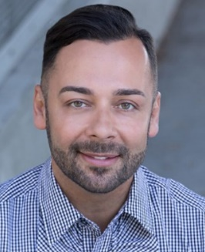**Edgar Villanueva**

Edgar Villanueva is an award-winning author, activist, and expert on issues of race, wealth, philanthropy, and ESG Investing. Villanueva is the Principal of Decolonizing Wealth Project and Liberated Capital and author of the bestselling book **Decolonizing Wealth**(2018, 2021). He advises a range of organizations including national and global philanthropies, Fortune 500 companies, and entertainment on social impact strategies to advance racial equity from within and through their investment strategies.

Villanueva holds a BSPH and MHA from the Gillings Global School of Public Health at The University of North Carolina at Chapel Hill. He is an enrolled member of the Lumbee Tribe and resides in New York City.

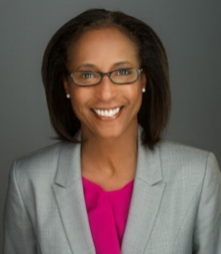**Dona Ponepinto**

**President and CEO, United Way of Pierce County**

Dona has been the President and CEO for United Way of Pierce County since 2014 and has been with the United Way movement for more than 30 years. Locally she led a ground-breaking tristate research project on the financial stability of families, deployed navigation specialists for South Sound 2-1-1, launched seven Center for Strong Families sites and serves on the Governor’s Poverty Work Group. In 2022, in partnership with the City of Tacoma, she and her team led the Guaranteed Income Demonstration project that provided $500 a month to 110 ALICE families. Dona holds a BA in Psychology and a Masters in Counseling with an emphasis in children and families from Creighton University.

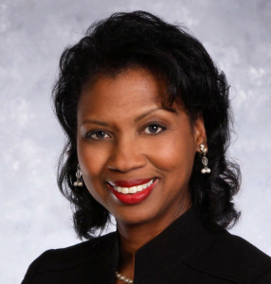**Carol C. Mitchell, J.D.**

**Founder, Institute for Black Justice**

Carol C. Mitchell holds a Juris Doctor from Seattle University School of Law, a Master of Arts in Organizational Systems Renewal from Seattle University, and a Bachelor of Arts in Sociology from the University of Washington Seattle. She founded the Institute for Black Justice (IBJ) in September 2020. The purpose of the IBJ is to relentlessly pursue equity and justice for all.

Mitchell has more than 20 years of public sector leadership experience, having served most recently in Pierce County, Washington. Her primary responsibility was to improve outcomes for individuals with behavioral health and substance use conditions who were caught in the grip of the criminal justice system. She has significant organizational and human resources experience, having served as the Chief HR Officer for the Port of Tacoma, Chief Organizational Development and HR Officer for Metro Parks, Public Relations Officer for Pierce Transit, and as Executive Consultant for her own preventive law firm.

Mitchell spent 17 years as the host of TV Tacoma's "CityLine," a public affairs talk show. Her volunteer activities include an appointment to the Board of Trustees of Clover Park Technical College, Past President of the Fair Housing Center of Washington Board, past member of the Palmer Scholars Board of Directors, and Past President of the Tacoma City Association of Colored Women's Clubs, Inc. She is proud to be in service to her community, to her soon-to-be-85-year-old mother, her 3 adult children and her 6 grandchildren.

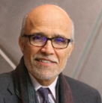**Dr. Ali Modarres**

**Dean, School of Urban Studies, Assistant Chancellor for Community Partnerships at University of Washington Tacoma**

Ali is the Dean of the School of Urban Studies and Assistant Chancellor for Community Partnerships at University of Washington Tacoma. He has published in the areas of social geography, immigration, urban development, planning, and policy. A significant portion of his public scholarship focuses on economic development and global labor migration through an

equity lens.

**Katie Condit**

**CEO, WorkForce Central**

Katie Condit is the CEO for WorkForce Central, Pierce County’s workforce development board. WorkForce Central bridges the gap between employers and workers through coaching, training, job placement and retention support with the aim of building and sustaining a robust talent pipeline into living wage jobs.

# Steven Cole-Schwartz

**Vice President of Grantmaking, Inatai Foundation**

Inatai Foundation is a 501©(4) grantmaking organization that is committed in its bones to transforming the balance of power in Washington. Steven guides the culture, processes, and systems of Inatai’s grantmaking programs, through which the organization provides resources community organizations that share our vision of a more racially just, equitable Washington. The Grantmaking department directly manages more than $40 million of grants each year; additionally, the department’s Grantmaking Operations and Program Management teams support other leaders inside Inatai to plan, manage, and facilitate an additional $25 million in grants and contributions. Steven joined Inatai (then, Group Health Foundation) in 2019 as the first member of the foundation’s program team and has served on the executive leadership team since that time.

Prior to joining Inatai, Steven served as the founding executive director of The Partnership Funds, a national funder collaborative dedicated to winning accountable, multi-racial political power in states around the country. Steven has built and owned his own consulting business, whose clients included national philanthropies, donors, and international labor unions. He served as a senior leader at the Tides family of organizations and was an early staff member at Ballot Initiative Strategy Center

Steven currently serves on the Board of the Amalgamated Charitable Foundation, an organization that supports donors to move money efficiently to leaders and organizations on the frontlines of social change. He is past co-chair of the Funders’ Committee for Civic Participation, a membership organization committed to voter engagement and community participation in policy advocacy and elections. He served on the governing board of the Alliance for Youth Organizing and was a founding board member of the Ohio Transformation Fund, among other grantmaking collaborations.

Steven grew up outside of Minneapolis, MN. He went to college in Omaha, NE, where he learned formative lessons about organizing, politics, and his own queer community, prior to working on political campaigns. Steven lived in Washington, D.C. for 15 years, where he met and married his husband. He and Michael now live in Seattle as guests on the homelands of the Duwamish and Suquamish people.

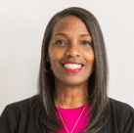**Sebrena Chambers, MPA, MBA**

**Director of the Strengthening Families/Community Health Division**

**Tacoma-Pierce County Health Department**

She is the current Chair of the United Way of Pierce County Board of Directors and has been a board member for eleven years. She is the Director of the Strengthening Families/Community Health Division for the Tacoma-Pierce County Health Department. Sebrena has been with the health department for twenty-seven years. She was raised in Tacoma and has always been active in her community, serving on many community boards. She fosters **trust and collaboration**, ensuring all voices are at the table. “Empowering Communities, One Act of Service at a Time.”

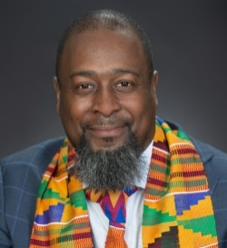**Drayton Jackson**

**Executive Director**

**Foundation of Homeless and Poverty Management**

Drayton Jackson's unwavering dedication to dismantling barriers, his passion for advocating for those affected by poverty and homelessness, and his record of leadership make him a powerful force in the ongoing quest for social justice. His inspiring journey and advocacy align with the United Way's mission to create lasting, positive change within our communities.

Drayton Jackson, a passionate advocate for change and equity, stands at the forefront of the mission to dismantle barriers in the way of individuals and families grappling with poverty and homelessness. With a deep commitment to making a difference, Drayton has garnered recognition and played vital roles in various initiatives aimed at alleviating these issues.

Drayton's dedication to creating a more inclusive society led to his appointment as the co-chair of Governor Jay Inslee's Poverty Reduction Work Group (PRWG) and its Steering Committee. In this capacity, he was instrumental in developing strategies and recommendations that laid the foundation for a comprehensive 10-year plan to combat poverty in Washington.

His passion for advocacy reached its zenith in 2020 when he founded the Foundation of Homeless and Poverty Management, a non-profit organization dedicated to addressing the burgeoning homeless population in Washington state. Drawing on his personal experiences with poverty and homelessness, Drayton steered the organization towards becoming one of the leading non-profits in Kitsap County, providing over three hundred thousand dollars in rental assistance to help house families and individuals during the pandemic.

As Executive Director, Drayton spearheads the organization with a visionary two-generational approach, guiding families from homelessness to stable housing. Beyond his work with the foundation, Drayton is also an elected official and currently serves as the Central Kitsap School District Board of Directors President. In addition, he plays a vital role on the Kitsap Public Health Board, further demonstrating his commitment to improving the lives.

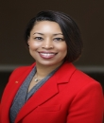**Cassandra Mitchell**

**Senior Vice President, Diversity, Equity, and Inclusion Strategy and Engagement**

**KeyBank**

Cassandra Mitchell joined KeyBank in 2012 rising up the ranks and holding multiple roles including as their Western Region Sr Talent Advisor, the Pacific NW Region Corporate Responsibility Officer, and most recently joining Key’s Diversity, equity and Inclusion team. In 2021, Cassandra was named KeyBank’s Senior Vice President and Diversity, Equity & Inclusion Strategy and Engagement Leader, a national role where she serves as a strategic partner to senior executives to deliver on KeyBank’s DE&I commitments and as a strategic advisor to employee resources groups and line of business partners across the enterprise. Outside of Key, Cassandra is passionate about investing, advocating for and supporting communities across the Seattle and Tacoma area. She currently serves on four non-profit boards which include; the Board of Directors for YWCA Seattle-King County, Community Roots Housing, Sound Outreach and currently Board Chair for Foundation for Tacoma Students

**Breakout - Connecting Resources for Pierce County Residents**

**C. Lynn Willis, Director of Family Stability Initiatives**

**C. Lynn Willis**

**Director of Family Stability Initiatives**

**United Way of Pierce County**

C. Lynn Willis calls Chicago, Illinois, home. She earned her bachelor’s degree in Communication Arts from Cheyney University of Pennsylvania in 1990 while pursuing an Associate of Science in Air Transportation from the Community College of the Air Force. In 1999, she obtained her master’s degree from Troy University in Foundations of Education with a Concentration in Leadership. Shortly after her college graduation in 1991, she dedicated 25 years of service to the United States Air Force Reserves, gaining leadership and organizational skills.

Since 2022, Ms. Willis joined United Way of Pierce County as the Director of Family Stability Initiatives. She leads the strategic development of the Center for Strong Families, provides leadership in growing the network and identifying new partners, tracks and manages performance benchmarks, plays a key role in scoping, developing, and managing regional projects and community impact partnerships.

Ms. Willis is a board member of the Golden 22 Foundation, a board member of the SPEAR Foundation Inc, and a member of the National Coalition of Black Women, 100 Women of Seattle.

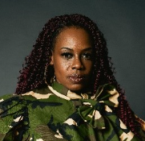**S****hellie Willis**

**Senior Director of Collective Impact**

**Workforce Central**

Shellie Willis is the Senior Director of Collective Impact Workforce Central, the public workforce development council serving employers and job seekers in Tacoma and Pierce County. Shellie serves as an advocate for system partners and the community by facilitating the Pierce County Community TaskForce and provides education and training on continuous quality improvement opportunities and increases access to education and employment by intentionally working with local elected officials, community partners and employers to solve complex problems in a structured way to design and create and equitable result.

Shellie is also the Founder of “Redefining You Foundation,” a 501© 3 non-profit organization that supports and empowers transitioning service women, women veterans, and military spouses redefine their lifestyles and perspectives following military service. She is a 24-year veteran of the US Army and holds a Master’s Degree in Management- Nonprofit Administration from the University of Maryland, Global Campus.

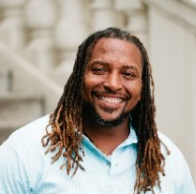**Tamar Jackson**

**Senior Director of Community Engagement**

**WorkForce Central**

Tamar Jackson is the Senior Director of Community Engagement at WorkForce Central, dedicated to forging a society grounded in equity, acknowledgement, and inclusivity. His innovative spirit is the driving force behind the Pierce County Community Engagement Task Force, a transformative initiative powered by WorkForce Central.

At the forefront of this pioneering task force, Tamar and his community engagement team have orchestrated the convergence of nearly 300 professionals and organizations spanning across Pierce County. This dynamic network collaborates synergistically, utilizing a comprehensive joint assessment methodology to scrutinize policies, exchange best practices, and allocate resources through a lens of racial equity. Tamar’s unwavering commitment to nurturing unity and collaboration among major systems and providers stands as a beacon of inspiration.

Tamar Jackson is more than a community leader; he is a catalyst for profound change. His tireless endeavors in community engagement, empowerment, activism, and advocacy are reshaping the landscape of Pierce County, leaving an indelible mark on the journey toward a more just and inclusive society.

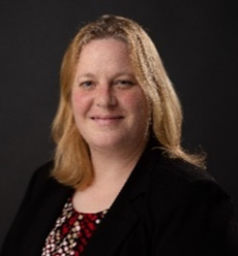**Kelly Brickhouse**

**Community Engagement and Outreach Coordinator**

**Workforce-Central,**

Kelly Brickhouse stands as a powerful force in her community, fueled by an unwavering passion for change. With a deep understanding of the struggles faced by many—homelessness, poverty, addiction—Kelly, herself, has weathered these storms. She is not just an advocate; she is a living testament to resilience.

A founding member of the Pierce County Community Engagement Taskforce, Kelly's dedication to uplifting her community knows no bounds. Her advocacy reaches the highest echelons of power, as she fearlessly addresses Federal, State, and local lawmakers, ensuring that the laws and policies enacted also safeguard the vulnerable. Through her leadership in Collaboration for a Cause and Hire 253, she has touched the lives of over 10,000 individuals and families in Pierce County, reaching out to those often left in the shadows.

As the Community Engagement and Outreach Coordinator at Workforce-Central, Kelly continues to pioneer transformative initiatives, illuminating the complex pathways to support and opportunity. Her story is not just one of personal triumph; it is a beacon of hope, guiding her community toward a future where compassion and equity prevail. Kelly Brickhouse stands tall, inspiring change and forging a legacy of empowerment for generations to come.

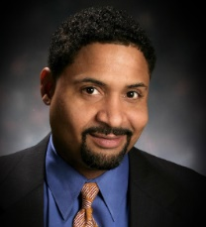**Norman Brickhouse**

**Manager, Fife Job Program**

**City of Fife**

Norman Brickhouse brings a decade of nonprofit experience to the table, with a unique background in the mortgage industry. His journey began by empowering individuals through financial education, instilling financial literacy, and coaching them on effective money management to achieve their goals, especially as they embarked on new career paths. Norman's unwavering commitment to serving the homeless population led him to the City of Fife, where he currently serves as the manager of the Fife Jobs program. In this role, he oversees a small village community dedicated to providing education, training, housing, and essential resources to support individuals experiencing homelessness on their journey towards success.

Furthermore, Norman plays a pivotal role as the co-lead of the Pierce County Community Engagement Taskforce's Outreach and Engagement Initiative. In this capacity, he continues to bridge the gap between the community and valuable resources, facilitating meaningful connections and opportunities for employment through collaborative efforts. Norman Brickhouse is a dedicated advocate for creating positive change and improving the lives of individuals in need.

**Breakout - Breaking Down Barriers Through a Guaranteed Basic Income**

**Facilitator - Abigail Lawson**

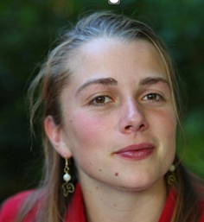**Abigail Lawson**

**Director, Guaranteed Income Program / Manager, Community Impact**

**United Way of Pierce County**

Abigail Lawson currently serves as the director of Tacoma, Washington’s guaranteed basic income program, Growing Resilience In Tacoma (GRIT) for United Way of Pierce County, consults across the country on designing empathetic and compassionate programs that center lived experience, and volunteers with regional nonprofits in both hands-on and board member roles. Abigail is a University of Washington Tacoma alumni with studies focused on economics, political science and philosophy. She is dedicated to building a bridge between our innate humanity and our economy, changing the narrative on poverty and deservedness, empowering anti-racist community-designed programs, and supporting the growth of resilient families and economies.

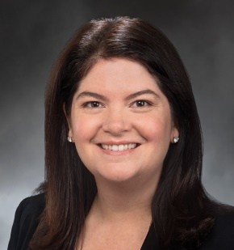**Liz Berry**

**State Representative**

Liz Berry represents Washington’s 36th Legislative District, located in the shadow of the Space Needle. Liz serves as Chair of the Labor & Workplace Standards Committee and is a member of the Environment & Energy and Transportation committees, where she is a passionate advocate for working families, combating climate change, and building vital infrastructure that is safe, equitable, and green. She also serves as a member of the Legislative Committee on Economic Development and International Relations, and as an alternate member of the Pacific NW Economic Region Delegate Council, a regional U.S.-Canadian partner organization that works to increase economic competitiveness and protect the natural environment. Liz previously led the region’s largest civil justice advocacy organization dedicated to standing up for the legal rights of patients, consumers and injured workers. A lifelong champion for women in leadership and reproductive justice, Liz served as president of the National Women’s Political Caucus of Washington and as a board member for Pro-Choice Washington. Liz has also been the lead sponsor for both of Washington's statewide guaranteed basic income bills.

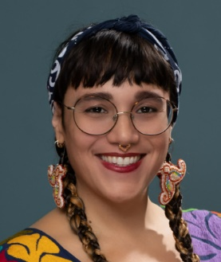**Patanjali de la Rocha**

**Program Director**

**The Nest, Hummingbird Indigenous Family Services**

Patanjali de la Rocha(they/them) is a queer Indigenous survivor, doula and perinatal health educator, herbalist, activist, health equity consultant, and parent living in Occupied Duwamish Territory (Seattle, WA). They specialize in anti-oppressive organizational healing, and decolonizing research by reclaiming evaluation and data through community-engaged practice. Their reproductive justice work includes working with carcerality-involved pregnant people to develop peer-led classes and perinatal health toolkit for the carceral system. They also serve as a lead member for the Washington State Maternal Mortality Review, and a member of the UCLA Center for the Study of Racism, Social Justice, and Health's COVID-19 Equity Taskforce. They currently work as a Program Director at Hummingbird Indigenous Family Services, launching the first Guaranteed Income pilot to exclusively serve Indigenous communities in the United States. This pilot program will provide 150 Indigenous pregnant people with $1250 a month from pregnancy until their child's 3rd birthday.

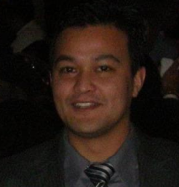**Gyanendra Subba**

**Project Manager, Workforce Development Council of Seattle-King County**

Gyanendra is an accomplished professional in the field of workforce development, leveraging over a decade of experience in direct service, research and evaluation, policy formulation, and management. His unique background as a former refugee from Bhutan, who grew up in a refugee camp Eastern Nepal, has provided him with invaluable insights into the complex challenges faced by marginalized communities. Currently serving as a project manager at the Workforce Development Council of Seattle King County (WDC), Gyanendra has assumed responsibility for overseeing multiple contracts. Notably, he has played a pivotal role in the Economic Security for All (EcSA) project, demonstrating his innovative approach by pooling resources to launch a guaranteed income program within the context of workforce development. He also holds a board position at the Somali Family Safety Task Force, underscoring his dedication to supporting vulnerable communities. With prior roles at the Seattle Housing Authority, Refugee Women’s Alliance, and the Nonprofit Assistance Center, Gyanendra has honed his expertise in addressing the multifaceted needs of marginalized communities. He holds an undergraduate degree in Physics, an MBA from Seattle University, a certificate in Social Impact Strategy from the University of Pennsylvania and a Public Leadership Credential from the Harvard Kennedy School.

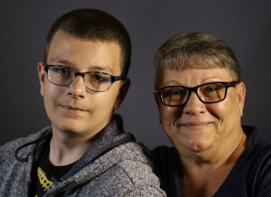**Debbie**

**GRIT Client**

Debbie Wilkerson is a grandmother, mother, and long-time Tacoma resident. Debbie has long worked in the food industry and now splits her time between part-time work and caring for her grandson, James. She is a gardener and a community advocate who supports a guaranteed basic income following her experience as a participant in United Way of Pierce County’s guaranteed income program, Growing

Resilience In Tacoma (GRIT).

**Breakout - Public Policy Lab - Disrupting the Status Quo**

**Jarrett Brunny, Vice President of Community Impact**

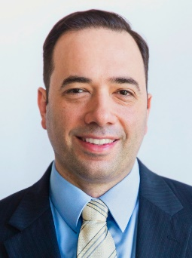**Jarret N. Brunny, PhD, MPH**

**Vice President of Community Impact**

**United Way of Pierce County**

Jarrett Brunny serves as Vice President of Community Impact at United Way of Pierce County, where he helps the organization bring people together to center community voice and break the cycle of poverty with a coalition of partnerships. Previously, he directed neighborhood-level collective impact efforts with United Way of South Hampton Roads in Norfolk, Virginia, working to reduce the opportunities gap in early education and to boost economic mobility. Brunny earned his doctorate in public health at the University of Florida and a Master of Public Health degree at the University of South Florida focusing on community, family, maternal, and child health. He has contributed to childhood lead poisoning prevention efforts within local health departments and has served as a consultant to federal grant initiatives within the Office of Minority Health (OMH) and the Office of Adolescent Health (OASH) at the U.S. Department of Health & Human Services.

**Shawn Paton**

**Sr. Director, Impact & Innovation**

**Kelvin Ceasar (KC)**

**Sr. Manager, Policy & Community Engagement**